“Charting the Path to a Relevant and Responsive Legal Education in the Philippines: A Draft Law Curriculum for the 21st Century Filipino Lawyer”

US Supreme Court Justice Felix Frankfurter captured the role and function of legal education when he said --

The law is in the last analysis what the lawyers are, and the lawyers are what the schools make them.

Indeed, laws are only as good as the people who craft, enforce and implement them. Hence, the foundation upon which this endeavor is built is on the staunchly-held view that if we want a working legal system, we need to put in place a working legal education--- one that is both relevant and responsive.

Recent developments both in the national and international fronts impacted the law program offering in the Philippines. Our Department of Education and our Commission on Higher Education have put in place major reforms in our basic education system by rolling out the K to 12 program and the Outcomes- based education for general education, respectively. On the other hand, and as the world becomes more and more borderless and technologically- progressive, it is faced with challenges that are both new and at times alarming: the prospects of terrorism, shortage of natural resources, and the indispensable need for states to depart from the isolationist outlook and to embrace a co-operative stance with other nations.

Humanity is faced with new reality, new challenges, new prospects, and the Filipino lawyer needs to be equipped to deal with the wind of change, both personally and professionally.

Current State of Law Program and Instruction

The law program in the Philippines used to be 122-unit program under the supervision of the Office of Private Education in 1946. It was increased to 134 units in 1963 and in 1989 through DECS Order No. 27. In 2011, through LEB Memorandum Order No. 1, the credit units were increased to 152 units for Bachelor of Laws (LLB) and 168 units for Juris Doctor (JD) by the Legal Education Board or LEB.

On the current law curriculum, it was that noted by the participants of the Regional Consultative Meetings (or RCM) that law schools focus on substantive law and procedural rules, primarily to prepare the student to take and pass the bar exams. The law curriculum is unanimously described to be heavily bar-centric, that is, the courses offered and taught were all based primordially on what is being tested in the bar. “Teaching to the test” was the keystone description. However, classroom knowledge does not translate to readiness to practice law. In many cases, and as noted by the judges- participants, a new lawyer does not even know what to say in court or how to prepare simple forms and pleadings.
Likewise, quite telling is the sharing of the participants that what the lawyers are expected to know depends on where they practice. For example, in Mindanao, there are many cases involving land and natural resources, therefore agrarian, natural resources and indigenous laws are important. Agrarian law is irrelevant, but mining law is relevant for the participants in the Baguio consultative meeting. Muslim lawyers are expected to know Shari'a law. There is increasing demand outside of Metro Manila for knowledge of commercial laws involving foreign investors, e.g. BPOs.
Participants also noted the need to look into the psychological and emotional preparedness in dealing with clients, other lawyers, judges using skills such as active listening, empathy, and professionalism. It was also noted that there is no training or orientation on the practical aspects of starting a private practice such as how to set up an office, record keeping or how to bill a client.
On curriculum content, there is broad agreement that the prescribed curriculum is theoretical and lacked training for practical application of the law studied in the classroom. This has changed in recent years with the introduction of internships, legal aid programs, student practice and the like. However, there is limited opportunity for internships for law students in smaller city centers and provinces.
In the RCMs in Davao, Cebu, Naga (in Hilton Manila) and Manila, the study and the results of the survey commissioned by Philippine Association of Law Schools (PALS), through Dean Nilo T. Divina, was presented. In this study, PALS commissioned the University of the Philippines School of Statistics to conduct a nationwide survey among lawyers on the usefulness of the courses being offered in the law curriculum of their time. Asked to rank the usefulness of the courses offered in their law program, the lawyers considered the following as extremely useful in their practice:
1. Obligations and Contracts
2. Legal Research
3. Legal Writing
4. Constitutional Law
5. Corporation Law
6. Criminal Law
7. Persons and Family Relations
8. Evidence
9. Sales
10. Property
11. Civil Procedure
12. Torts and Damages
13. Legal Technique and Logic
14. Labor Law

On the other hand, the following were considered least useful:
- Election Law
- Natural Resources and Environmental Law
- Private International Law
- Legal Medicine
- Human Rights
- Negotiable Instruments
- Insurance
- Banking and Finance
- Taxation
- Law on Public Officers
- Alternative Dispute Resolution
- Transportation Law
- Administrative Law
- Trial Technique
Also shared with the participants of the various RCMs was the draft curriculum crafted by the Committee formed by the Legal Education Board through its first Chairman, Justice Hilarion Aquino. The participants welcomed the proposed draft when it was presented in the plenary. On this draft curriculum, the Committee looked at global trends in legal education. It was noted that in the United States and Australia, there is a growing interest on outcomes- based education. In Asia, the National University of Singapore has taken the initiative of revising its law curriculum in 2012, noting the increasing internationalization of law practice in Singapore. It was also observed that in these jurisdictions, perspective courses on comparative international law were seen as a way of internationalizing the curriculum.
In addition, the load of the curriculum is given importance so as to give time for reflection. Reasonable connection has been noted to exist between reflection and critical thinking. Reflection solidifies knowledge by letting the students return to an experience to examine it, deliberately intending that what is learned may be a guide in future situations, and incorporating it into one's existing knowledge. Studies show that when students engage in reflection there is a connection to "deep learning". Thus, coverage plays a crucial importance in curriculum planning. In this regard, it was noted that most jurisdictions in Asia and the United States have a student load of maximum of 12 contact hours per week for the student. Only the Philippines and India have credit units exceeding 15.

Participants noted as well that the curricular load bears weight not only on learning but also on cost of education, which in turn has substantial impact on access to justice and rule of law considerations.
Insights and Observations

The common theme across all the seven RCMs conducted all over the country is that there is no “one size, fits all” law curriculum. The needs of the community and the law students are diverse as the geographical variations of the law schools all over the country.

Also, there was an expressed interest on an outcomes- based education (or OBE) as a teaching philosophy in law schools. OBE came about because of globalization. The ASEAN Economic Community Blueprint, for instance, seeks to achieve free flow of services by 2015. Mobility of professionals and skilled labor was planned to be implemented by mutual recognition arrangements and by the development of core competencies or the concordance of skills and qualifications for jobs/ occupational skills. Thus, was conceived the Asean Qualifications Reference Framework or AQRF. The Task Force for AQRF was then created to design AQRF that supports the development of mutually comparable National Qualifications Framework (NQF), that is, one that will contain learning outcomes, levels and domains of skills to enable comparisons of qualifications across participating ASEAN countries, allowing a scenario like this to happen:
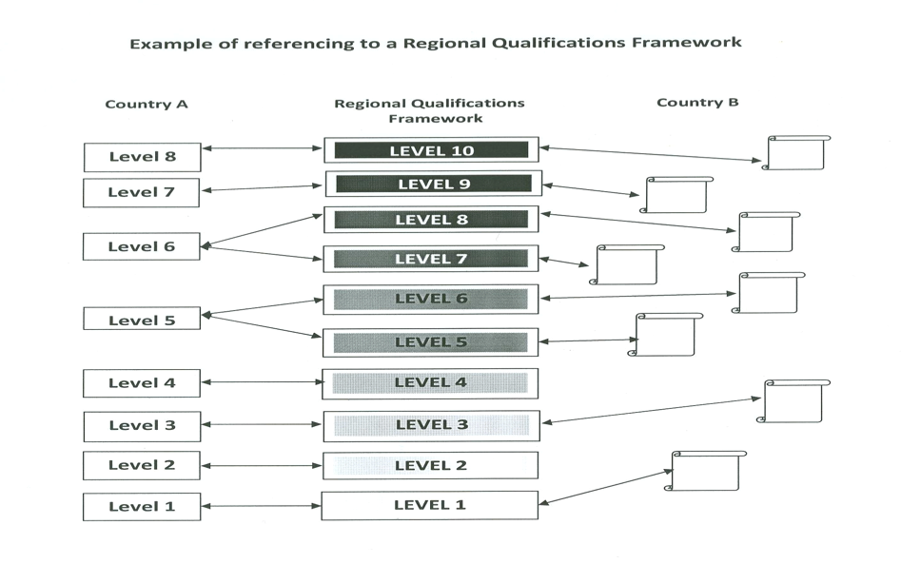
Thus was signaled the shift of Philippine higher education to an outcomes-based education or OBE. As announced in CHED Memorandum Order (CMO) No. 46, OBE is a paradigm shift in Philippine education system “from education to lifelong learning, and from education as transmission of expert knowledge to education as building learner competencies—including learning how to learn.

As a policy, OBE will require all higher education institutions (HEIs) to describe the attributes of their ideal graduates based on their visions and missions as part of their institutional goals or outcomes, and use these as bases for developing specific program outcomes. Program outcomes are the sets of competencies (related knowledge, skills, and attitudes) that all learners are expected to demonstrate. Institutional or program outcomes may also emphasize lifelong learning. These desired outcomes have to be translated to what the students learn in specific courses and HEIs must ensure that at the level of the courses, the desired course and learning outcomes are attained with the proper content, methodologies, and student performance assessment.
The concept is illustrated as follows:
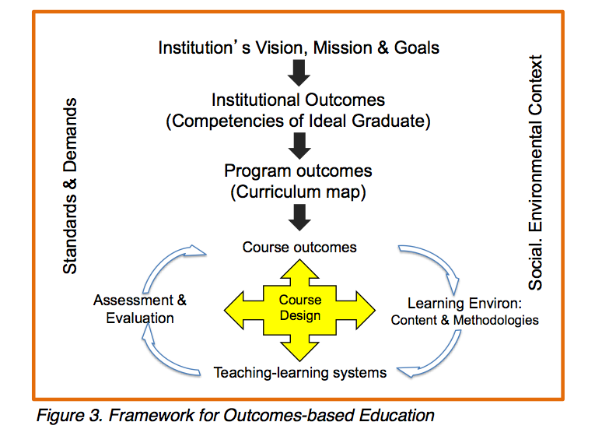

In the context of the law program, there has to be a set goal or outcome, and teaching and assessment are to be aligned and directed towards the attainment of the outcome.

In brief, an outcomes-based education is one that begins with an end in mind. Here, schools are mandated to state the intended graduate attributes and to see to it that these attributes are addressed in the courses offered and the manner by which these courses are taught. Otherwise referred to as “backward design,” OBE is described this way:

First, the educator identifies his goals for the course: what measurable results does he want? This is the outcomes identification phase. Second, the educator determines what achievement of those outcomes would look like. What is evidence of student proficiency? This is the assessment phase. Third, the educator develops teaching methods and materials that are designed to help students achieve the identified outcomes in a way that the educator can assess. This is the delivery phase (what we think of as “teaching”). Finally, the educator evaluates how well his design worked. Did the teaching result in measurable evidence that students achieved the outcomes and did students achieve the outcomes? This is the evaluation phase...
The principal challenge to education in the twenty-first century is to shift from a localized factory model to one that prepares citizens to function in an increasingly interconnected and rapidly changing globalized world. Literatures on education carry these lamentations: “[e]ducation today is largely out of sync with the realities of the global world. “There is a new tension between the glacial pace of institutional change in ministries of education and schools and the rapid social, economic and cultural transformations brought about by the forces of globalization”.

It was noted that the “people, culture and structures of higher education are not conducive to coherence; rather, the natural tendency is for individualism and specialization. It is very common for faculty in higher education programs not to have a collective and coherent view of the program in which they reside. In fact, many groups of faculty have never undertaken a discussion about what it is they want their students to know and be able to do at the culmination of the programs.”
In Best Practices for Legal Education and Carnegie Foundation’s Educating Lawyers, the common recommendation is for legal education to keep pace with the educational paradigm adopted by higher education a quarter of century ago--- an outcomes-based education. Best Practices observed that:
There is nothing more important for any educational institution than to have clearly articulated educational goals. A law school cannot determine whether it is achieving its educational goals unless the goals are clear and specific. A law school’s educational objectives should be published and made available to prospective and current students, alumni, and employers.
The educational goals of most law schools in the United States are articulated poorly, if at all. This is one of the primary reasons why most law school curriculums can best be described as chaotic: they lack cohesion, coordination, and common purpose, especially after the first year.
Thus, law schools are prodded to articulate their educational goals in terms of intended student outcomes, noting that “[w]hen objectives are not made explicit, the result is almost certainly a preoccupation with specific knowledge. If students are expected to develop a degree of independence in pursuit of learning, reach a satisfactory level of skill in communication, demonstrate sensitivity to their own values and those of their associates, become capable of collaborating with peers in defining and resolving problems, be able to recognize the relevance of their increasing knowledge to the current scene, and seek continually for insightful understanding and organization of their educational experience, these outcomes must be specifically stated. In addition, they must be made explicit in relation to learning experiences and by providing opportunities for demonstration of the developing behavior and for evaluation of it.”
In A Nation At Risk, it was said that American education in 1980s had been characterized by the absence of any defined student or institutional outcomes, the presence of incoherent curricula, and teachers operating in individual isolation.
When placed in a law school setting, the problem is, absent a defined mission and the identification of attendant student and institutional outcomes, a law school lacks focus and its curriculum becomes a collection of discrete activities without coherence. Lacking the guidance of an express mission or statement of student or institutional outcomes, the traditional law school curriculum is “deficient in both structure and coherence.” When the mission in legal education is nonexistent and student outcomes are not identified, one can predict that the teaching method will lack focus and be ineffective.
In the Philippines, an outcomes-based approach is entirely foreign to legal education. The tendency is to even reject it, sometimes deriding it as one that is needed only in the undergraduate courses. This is where a re-thinking needs to be done. For there is a reason why the Philippine higher education has shifted to an outcomes-based education. As established by numerous surveys, “students are more motivated to learn as part of a community of learners if they understand the long term and intermediate objectives of the program of instruction. Learning is also enhanced when students understand why certain instructional and assessment methods are employed.”

The criticism about law schools of “ignoring the constituencies that they serve, not knowing what lawyers do, what law students need to learn, how law students learn best, what teaching methods are most effective, how to determine whether students have learned, what responsibilities the law school has to the profession and to the society” may in fact be said also of Philippine law schools in general. When Karl N. Llewelyn lamented in 1935 that “no faculty and not one percent of law instructors knows what it or they are really trying to educate for”, he could have described a situation that persists close to a century after he made the observation.

The higher education system in the country has already shifted to an outcomes-based approach. A shift to an outcomes- based legal education will prevent a clear disconnect of the law program from the rest of the programs offered by all higher education institutions. More importantly, it will also promote and enhance quality learning in our law schools. It will serve as guidance for the teachers when they teach their respective courses. They will see their courses as part of the integrated whole. It will also serve as a motivation for the students as they will now see that the learning activities that they are required to undergo have an intended outcome. It is a means of promoting accountability of the law school to the students, the public and the community. As Nelson P. Miller aptly summarizes:

“A table of lawyer competencies enables a law school to align its curriculum, in a process known as curriculum mapping, to what the bar expects of law school graduates. Curriculum mapping makes particular sense, given the Carnegie Foundation report’s criticism that “faculty attention to the overall purposes and effects of a school’s educational efforts is surprisingly rare” mainly because faculty focus on only their areas while blindly following the self-replicating model of the elite schools. Curriculum mapping can help to create a professional learning community… Curriculum mapping also validates teaching to standards, providing not only guidance but accountability. .. Instructors readily discover what they are teaching but need not, what they are teaching and need to continue to teach, and what they are not teaching but should start to teach. It also fosters teamwork across an educational institution. Instructors can recognize how the competencies that they teach relate to the same or different competencies taught by others in the same institution and can coordinate instruction.”

Recommendations

Guided by the data, comments, context and insights culled from the RCMs, the following recommendations are proposed:

1. Law Curriculum. Bearing in mind the lawyering skills that are to be developed in the students, the results of the survey of courses most used in law practice, the inputs from judges, law professors and law practitioners in the RCMs, the core, perspective and skills courses were drawn up to comprise the proposed Juris Doctor or JD curriculum.

The core courses with their respective credit units (c.u.) are:

Constitutional Law 1 (3 c.u.)
Constitutional Law 2 (3 c.u.)
Criminal Law 1 (3 c.u.)
Criminal Law 2 (3 c.u.)
Persons and Family Law (to include Succession) (4 c.u.)
Obligations and Contracts (5 c.u.)
Property Laws (to include Property Registration Laws) (5 c.u.)
Torts and Damages (2 c.u.)
Criminal Procedure (3 c.u.)
Civil Dispute Resolution (5 c.u.)
Evidence (3 c.u.)
Business Organizations (Corporation Laws, Partnership, Agency)(6 c.u.)
Legal and Judicial Ethics (4 c.u.)

The mandatory perspective and skills courses are:

Comparative Legal Systems (2 c.u.)
Legal Analysis, Writing and Research (3 c.u.)
Public International Law (2 c.u.)
Conflict Management (2 c.u.)
Developmental Law (2 c.u.),

for a total of 60 mandatory credit units of core and perspective and skills courses. Legal Ethics and practical exercises will be integrated in all the core and perspective and skills courses of the curriculum.

The assignment of credit unit is engendered by the expressed sentiment of the participants that a heavy workload makes legal education expensive, thereby impacting on the access to justice of our people. The decision to limit the workload is also influenced in part by the practices of other law schools in the ASEAN Region, the UK, US, Canada and Australia. It was noted that the average contact hours is 12- 14 per week, and this is grounded on some pedagogical philosophy and practices. Learning is achieved when the students are given time for reflection, which is simply rendered impossible when students have heavy workload in a given week. Thus, the 15 contact hours as prescribed workload for the students, except for the third year of the JD program where students will have 17 contact hours and 19 contact hours, for first and second semesters, respectively for their thesis proposal hearing and thesis defense.

Hence, the total credit units for JD is 126 c.u. In the third and fourth years of the program, law schools are granted the flexibility to design tracks for their curriculum, and to offer elective courses that will respond to both global and local needs, and permit law schools to establish a niche, or pursue some branding.

In compliance with the Revised Law Student Practice Rule (Rule 138-A), Clinical Legal Education Program (CLEP) will be required in all law schools to enable the students to immerse themselves in the practice of law. Law students will be able to seek any or both of the two levels of certification, namely, Level 1 certification may be applied for by a law student who has finished the first year of his law studies. Level 2 may be applied for by one who has completed third year of law studies. Level 1 certification will allow the law student to render all legal services short of appearance in court, which is reserved for Level 2 certified law student practitioner. In both levels of certification, the law student practitioner engaging in limited practice of law will be supervised by a lawyer. It is aimed that CLEP will enable the law students to learn the law while serving the community.

Hence, the model law curriculum for JD program is proposed to be as follows:

YEAR 1
Semester 1 Semester 2
Constitutional Law 1 (3) Constitutional Law 2 (3)
Criminal Law 1 (3) Criminal Law 2 (3)
Persons and Family Law (5) Obligations and Contracts (5)
Comparative Legal Systems (1) Legal and Judicial Ethics (4)
Legal Analysis, Writing and Research (3)
Total c.u.- 15 Total c.u.- 15

YEAR 2
Semester 1 Semester 2
Criminal Procedure (3) Civil Dispute Resolution (5)
Conflict Management (2) Business Organization 2 (3)
Property Laws and Registration Decree (5) Public International Law (2)
Business Organization 1 (3) Evidence (3)
Torts and Damages (2) Developmental Law (2)
Total c.u.- 15 Total c.u.- 15

YEAR 3
Semester 1 Semester 2
CLEP (2 c.u.) *may be taken in the second yr CLEP (2 c.u)
Thesis Proposal (2 cu) Thesis Defense (4 cu)
Law school will adopt track/ tracks for the LLB programs with 13 c.u. per semester
Total c.u.- 17 Total c.u.- 19

YEAR 4
Semester 1 Semester 2
CLEP (2 c.u.) Life Skills and Personality Devt (2 cu)
Electives (13 c.u.) Electives (13 c.u.)
Total c.u.- 15 Total c.u.- 15

SUGGESTED TRACKS FOR JD PROGRAM

- General Law Practice & Litigation
  - Labor Law
  - Law on Trade Unionism
  - Succession
  - Human Rights
  - Special Issues in International Law
  - Agrarian Law
  - Special Proceedings
  - Environmental Law
  - Conflict of Laws
  - Legal Medicine
  - Natural Resources Law
  - Appellate Practice & Brief Making
  - Arbitration Laws
  - Women & Children’s Rights Laws
  - Gender Laws
  - Collective Bargaining
  - Estate Planning
  - Immigration Law & Procedure
  - Indigenous People & The Law
  - Technology & the Law
  - Intellectual Property
  - Public Corporations
  - Legal Counselling
  - Modes of Discovery
  - Street Law
  - Political Law Review
  - Criminal Law Review
  - Civil Law Review
  - Remedial Law Review
  - Sharia Law
  - Forensics

- Business Track
  - Labor Laws and Human Resource Management
  - Sales
  - Commercial Documents
  - Taxation Principles & Income Tax
  - Transfer & Business Tax and Remedies
  - Advanced Taxation
  - Human Rights
  - Credit Transactions
  - Insurance
  - Special Issues in International Law
  - Transportation
  - Natural Resources Law
  - Admiralty
  - Banking Laws
  - Arbitration Laws
  - Collective Bargaining
  - Consumer Protection
  - Corporate Finance, Governance & Practice
  - Mergers & Acquisitions
  - Indigenous People & The Law
  - Estate Planning
  - Technology & the Law
  - Intellectual Property
  - Investment Laws
  - Franchising Laws
  - Securities, Public Offerings & Stock Exchange Listing
  - Laws on Importation, Tariff and Customs
  - Legal Accounting
  - Real Estate Transactions
  - European Business Law
  - ASEAN Business Law
  - Political Law Review
  - Criminal Law Review
  - Civil Law Review
  - Remedial Law Review
  - Sharia Law
  - Special Commercial Laws
  - Commercial, White-Collar and Cyber Crimes
  - Commercial (Domestic and International) and Industrial Arbitration

- Government and Judicial Track
  - Human Rights
  - Special Issues in International Law
  - Administrative Law and Public Officers
  - Natural Resources Law
  - Government Contracts and Procurement Law
  - Immigration Law & Procedure
  - Indigenous People & The Law
  - Public Corporations
  - Local Government Finance
  - Law & Economic Development
  - Political Law Review
  - Criminal Law Review
  - Civil Law Review
  - Remedial Law Review
  - Sharia Law
  - Judicial Logic and Judgment Writing
  - Legislative Process and Procedure
  - Civil Service Laws & Public Administrative Systems

The law schools are free to offer other elective courses.

It is suggested that the tracking programs for those entering the government service (e.g. judiciary, PAO, prosecution) are to be offered by law schools of state universities as mandatory course offerings, and as an option for private educational institutions.

1.1. Bar Exam Coverage, the Law Curriculum and the Supreme Court’s authority over both. The participants in the RCMs highlighted the inextricable link between the law curriculum and the Bar Examinations. Law schools put much focus and emphasis on the courses that are tested in the Bar Examinations. Hence, it was the expressed view of the participants that there should be close coordination in the crafting of the bar coverage and the contents of the law curriculum. What are to be tested on substantive knowledge are the courses categorized as core courses and the Bar examinations ought to test lawyering skills so as to highlight the need to develop these skills in the students while in law school.

Based on the above curriculum, the suggested Bar Examinations subjects are:

Political Law (20%)
Civil Law and Business Organizations (30%)
Criminal Law (20%)
Remedial Law (30%), with ethics questions integrated in ALL these bar subjects.

It may also be that the bar coverage will only be certain topics falling within these major bar subjects.

2. Law Instruction. Ethics is suggested to be taught pervasively as the Bar examinations will integrate ethics in all bar subjects. In line with OBE, the law schools are encouraged to set program outcomes and develop course outcomes and teaching methods corresponding to the outcomes.

Among the felt need and the intended program outcomes are for the students to have a strong grasp of knowledge of the law embedded in the core courses. Further, it was expressed in the RCMs that law schools ought to develop lawyering skills in their students. In particular, the following skills: case analysis, litigation-oriented skills, problem solving skills, negotiation skills, and writing skills. The values of professionalism and ethical practice of law were also highlighted as among the intended outcomes of the law program.

With the amendment of Rule 138-A making mandatory the offering of CLEP in all law schools, law professors will now be adopting experiential learning as another teaching methodology. Teaching methods other than Socratic method are recommended to be used such as simulation exercises, mooting and small group discussions. Law schools are to be guided by the goal of achieving an alignment between the program outcomes and the teaching and assessment methods used to achieve these outcomes.

It is likewise recommended that technology be taken advantage of by the law schools and best practices be regularly shared among law professors and law deans.

3. Centers of Excellence. To enable best practices to flourish, Centers of Excellence (COE) are recommended to be established. Law schools classified as COEs will then be given autonomy in crafting their curriculum.

The goal of the proposed reforms in legal education is to make the law program relevant and significant to the legal profession and to the local and global communities. After all, the age-old purpose of education has always been to prepare one for a life of usefulness in the society. To enable the law schools to perform this function, it is hoped that academic freedom will be respected and promoted. This has to be so, if we are to aim for what Chief Justice Lucas Bersamin has said about law schools as places of creativity, and, if it may be boldly added, places of service and of innovation.#

See Strategic Schedule for ASEAN Economic Community, pp. 49-50, ASEAN Economic Community Blueprint, Jakarta: ASEAN Secretariat January 2008.
Source: Professional Regulation Commission.
See Article III, CMO 46, last accessed at http://www.ched.gov.ph/wp-content/uploads/2013/07/CMO-No.46-s2012.pdf on August 25, 2014.
Id., Part III.
Carolyn Grose, “Outcomes-Based Education One Course at a Time: My Experiment with Estates and Trusts”, last accessed at http://papers.ssrn.com/sol3/papers.cfm?abstract_id=1663327 on August 7, 2014.
See Learning in the Global Era, International Perspectives on Globalization and Education by Marcelo M. Suarez- Orosco, University of California Press Berkeleyand Los Angeles, California, 2007.
Id.
See From Teaching Globalization to Nurturing Global Consciousness by Veronica Boix Mansilla and Howard Gardner, published in Learning in the Global Era, supra.
Deborah Maranville, Kate O’Neill, Carolyn Plumb, Lessons for Legal Education from the Engineering Profession’s Experience with Outcomes- based Accreditation, at http://www.wmitchell.edu/lawreview/Volume38/documents/4.Maranville.pdf last accessed on August 21, 2019.
http://www.cleaweb.org/Resources/Documents/best_practices-full.pdf last accessed on August 21, 2019.
http://www.carnegiefoundation.org/sites/default/files/publications/elibrary_pdf_632.pdf last accessed August 21, 2019.
See http://www.cleaweb.org/Resources/Documents/best_practices-full.pdf last accessed on August 21, 2019 at p. 39.
Id at p. 39-40.
See http://datacenter.spps.org/uploads/sotw_a_nation_at_risk_1983.pdf last accessed on August 21, 2019.
See Gregory S. Munro, Outcomes Assessment for Law Schools, last accessed at http://lawteaching.org/publications/books/outcomesassessment/munro-gregory-outcomesassessment2000.pdf on August 21, 2019.
Id, pp. 3-4.
Id, at p. 52, citing Roger Cramton, The Need for Greater Emphasis on Skills Development, Remarks at the National Conference on Legal Education- Curricula for Change.
Id at p. 54.
See Best Practices at http://www.cleaweb.org/Resources/Documents/best_practices-full.pdf last accessed August 21, 2019.
See Gregory S. Munro, Outcomes Assessment for Law Schools, last accessed at http://lawteaching.org/publications/books/outcomesassessment/munro-gregory-outcomesassessment2000.pdf on August 21, 2019, p. 46.
Cited at Munro, p. 46.
Mapping Lawyer Competencies onto the Law School Curriculum to Confirm that the Curriculum Prepares Graduates for Practice, last accessed at Social Science Research Network’s http://papers.ssrn.com/sol3/papers.cfm?abstract_id=2461037 on August 21, 2019.

